DMA PTA
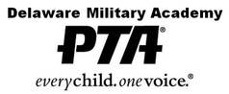
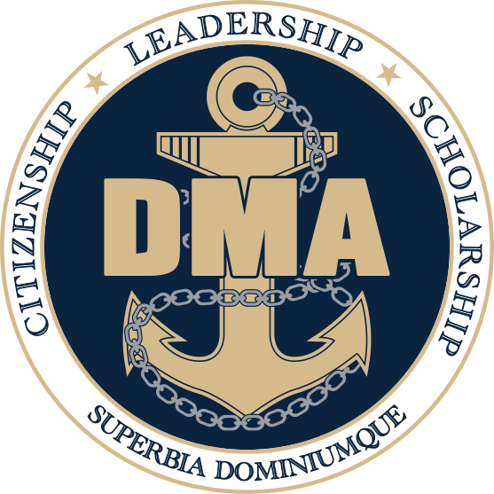
Meeting Agenda
February 19, 2026

- Call Meeting to Order and Welcome: Jen Avery
- Commandant’s Report: Dan Newcott
- Secretary: Sue Cressman

- Treasurer’s Report: Pam Bargren

- Vice President(s) Report: Hilary Raptis
- VP Communications Report: Danielle Wenzel
- Committee Reports:
- Activities Committee Erin Marino
- Friday Lunch Cynthia Mistretta
- Hospitality Hilary Raptis
- Military Support Ashley Hitzig & Chris Clawson
- Staff Appreciation Stacey Chakwin
- Membership Brooke Terranova

- Old Business
- Oct, Nov, Dec 2025, and Jan 2026 Financials & Minutes
- DMA PTA 2026/2027 Outlook

- New Business

- Motion to Adjourn
Next General Membership Meeting:
March 19, 2026

**Important Dates**
PTA Meeting Dates: (may be subject to change)
March 19, 2026
April 16, 2026 *Elections*
May 21, 2026

Other PTA Involved Activities
Service Academy Night 9/11 Ceremony Back to School Night
Choice Open House Veteran’s Breakfast Food Drive
Dining In Academic Awards Night NJROTC Awards Night
Jr. Ring Ceremony NHS Induction Senior Breakfast
End of Year Picnic New Cadet Orientation & Picnic

PTA Fundraising
The PTA sells a pizza lunch every Friday – It is our primary fundraiser.
Please consider signing up for Friday lunch help. We rely on volunteers to help make it successful.

*Upcoming Important Dates*
Feb 23rd – DMA School Board Meeting @6pm
Feb 25th – AMI
Feb 27th – Spring Blood Drive
Mar 10th-11th – Prom Ticket Sales (during lunch)
Mar 12th – Sports Boosters Meeting @6:30pm
Mar 13th – PSAT 10th & 11th
Mar 20th – MP3 Ends
Mar 23rd – DMA School Board Meeting @6pm
Mar 23rd – Virtual Day
Apr 2nd – Service Academy Night 6-8pm
Apr 3rd-10th – School Closed Spring Break
Apr 13th – Spoorts Boosters Meeting @6:30pm
Apr 15th – NHS Induction
Apr 21st – Junior Ring Ceremony
Apr 25th – Class of 2030 Academic & PT Test 7:30am
Class of 2030 Orientation 11:30am
Apr 27th – DMA School Board Meeting @6pm

