**DMA PTA**

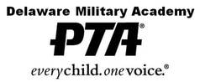

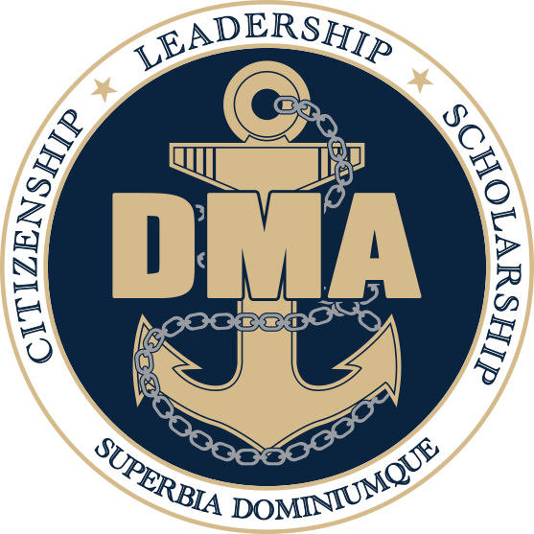

**Meeting Agenda**

**October 17, 2024**

1. **Call Meeting to Order and Welcome: Jen Avery**
2. **Commandant’s Report: Dan Newcott**
3. **Secretary: Sue Cressman**
4. **Treasurer’s Report: Lee Sobocinski**
5. **Vice President(s) Report: Renee Hafer**
6. **VP Communications Report: Kristin Hainsworth**
7. **Committee Reports:**

* Activities Committee Erin Marino
* Friday Lunch Cynthia Mistretta
* Hospitality Hilary Raptis
* Military Support Ashley Hitzig & Chris Clawson
* Staff Appreciation Stacey Chakwin
* Membership Danielle Wenzel

1. **Old Business**
2. **New Business**
3. **Motion to Adjourn**

**Next Meeting:**

**November 21, 2024 @6:30pm**

**\*\*Important Dates\*\***

**PTA Meeting Dates: (may be subject to change)**

November 21, 2024 @6:30pm

December 19, 2024 @6:30pm

January 16, 2025 @6:30pm

February 20, 2025 @6:30pm

March 20, 2025 @6:30pm

April 17, 2025 @6:30pm

May 15, 2025 @6:30pm Elections

**Other PTA Involved Activities**

Service Academy Night 9/11 Ceremony Back to School Night

Choice Open House Veteran’s Breakfast Food Drive

Dining In Academic Awards Night NJROTC Awards Night

Jr. Ring Ceremony NHS Induction Senior Breakfast

End of Year Picnic New Cadet Orientation & Picnic

**PTA Fundraising**

The PTA sells a pizza lunch every Friday – It is our primary fundraiser.

Please consider signing up for Friday lunch help. We rely on volunteers to help make it successful.

https://www.signupgenius.com/go/30E0B4EAFAD2DABFF2-50118473-friday

**\*Upcoming Important Dates\***

Oct 17th 6pm Parent Council Meeting

Oct 26th 8:30am Open House for 8th Graders

Oct 28th – Nov 1st SPIRIT WEEK

Oct 28th 6pm DMA School Board Meeting

Oct 29th 5:30pm Power Puff Game

Nov 2nd 7-10pm Homecoming

Nov 3rd Daylight Savings – “Fall Back”

Nov 4th VIRTUAL DAY for Cadets

Nov 5th NO SCHOOL – Election Day

Nov 6th 7:30am-9am Veterans Breakfast

Nov 7th Midterms Block 1 & 2 Dismissal at 11:20

Nov 8th Midterms Block 4 & 5 Dismissal at 11:20

Nov 11th NO SCHOOL

Nov 18th 6pm DMA School Board Meeting

Nov 19-20th Junior Ring Sales

Nov 21st 6:30pm PTA Meeting

Nov 25th VIRTUAL DAY for Cadets

Nov 26-29th NO SCHOOL – Thanksgiving Break