DMA PTA
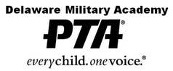
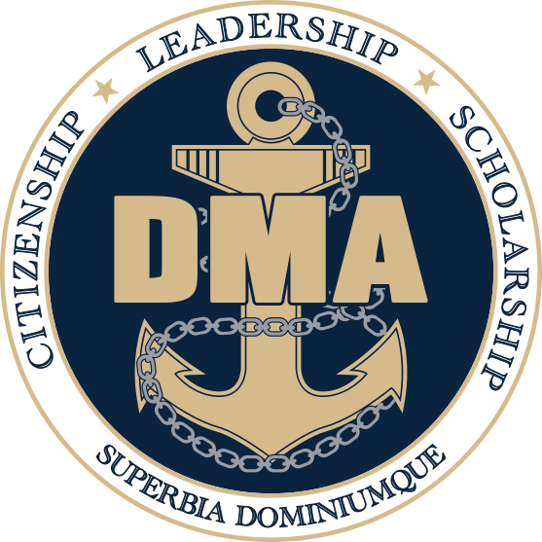
Meeting Agenda
January 15, 2026

- Call Meeting to Order and Welcome: Jen Avery
- Commandant’s Report: Dan Newcott
- Secretary: Sue Cressman

- Treasurer’s Report: Pam Bargren

- Vice President(s) Report: Hilary Raptis
- VP Communications Report: Danielle Wenzel
- Committee Reports:
- Activities Committee Erin Marino
- Friday Lunch Cynthia Mistretta
- Hospitality Hilary Raptis
- Military Support Ashley Hitzig & Chris Clawson
- Staff Appreciation Stacey Chakwin
- Membership Brooke Terranova

- Old Business
- New Business
-26/27 Officers and Committees
- Motion to Adjourn
Next General Membership Meeting:
February 19, 2026

**Important Dates**
PTA Meeting Dates: (may be subject to change)
February 19, 2026
March 19, 2026
April 16, 2026 *Elections*
May 21, 2026

Other PTA Involved Activities
Service Academy Night 9/11 Ceremony Back to School Night
Choice Open House Veteran’s Breakfast Food Drive
Dining In Academic Awards Night NJROTC Awards Night
Jr. Ring Ceremony NHS Induction Senior Breakfast
End of Year Picnic New Cadet Orientation & Picnic

PTA Fundraising
The PTA sells a pizza lunch every Friday – It is our primary fundraiser.
Please consider signing up for Friday lunch help. We rely on volunteers to help make it successful.

*Upcoming Important Dates*
Jan 13th – Jan 16th Midterm Exams – 11:20 Dismissal
Jan 16th – End of 2nd MP
Jan 19th – NO SCHOOL
Jan 20th – Virtual Day
Jan 26th – DMA School Board Meeting
Feb 9th – Community Service Day – NO SCHOOL
Feb 11th – Spring Meet the Coaches @6:30pm
Feb 12th – Sports Boosters Meeting @6:30pm
Feb 16th – NO SCHOOL
Feb 23rd – DMA School Board Meeting @6pm
Feb 25th – AMI
Feb 27th – Spring Blood Drive

